Role Hierarchy

Assume you start a company and you are going to recruit people for different roles. Before that, you have to design the roles and its hierarchy. So to make it simple, I have developed a program that creates and maintains roles and its hierarchy. See the example role hierarchy below.

And also I have included few operations that can be performed and also provided the sample input and output here.

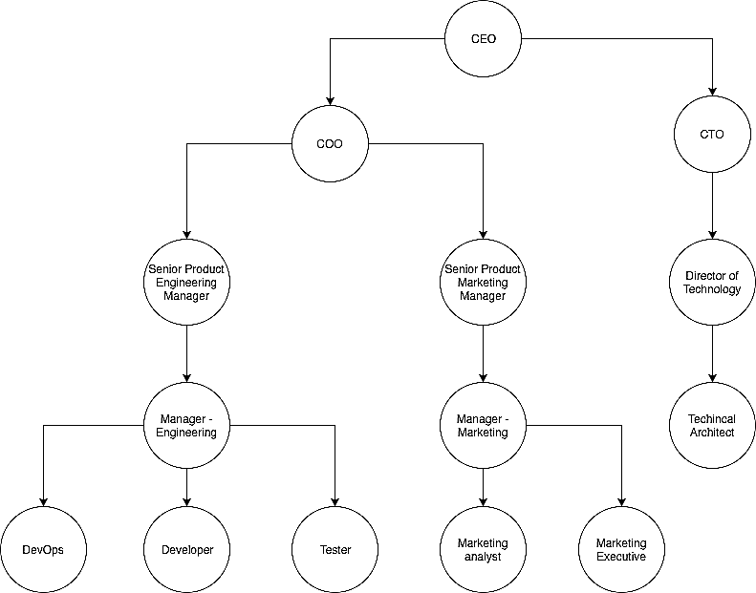

**Q uestion 1 :**

Create the root role and display it.

# Sample Input :

Enter root role name : CEO

# Sample Output :

CEO

**Q uestion 2 :**

Now support the add sub role operation to the root role

# Sample Input :

Enter root role name : CEO Operations :

1. Add Sub Role.

Operation to be performed : 1 Enter sub role name : COO

Enter reporting to role name : CEO Operations :

1. Add Sub Role.

Operation to be performed : 1 Enter sub role name : CTO

Enter reporting to role name : CEO

# Sample Output :

CEO COO CTO

**Q uestion 3 :**

Now the sub role can be added to any role. And also display the roles in role hierarchy order.

The role hierarchy order of the above tree would be CEO, CCO ,CTO, Senior Product

Engineering Manager, Senior Product Marketing Manager, Director of Technology and

so on.

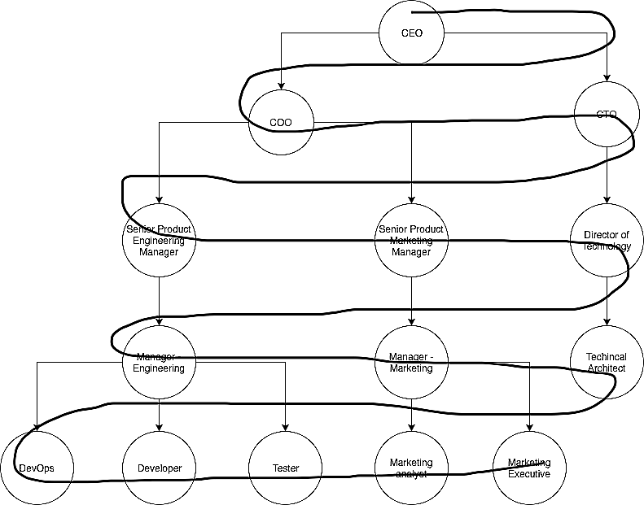

# Sample Input and Output :

Enter root role name : CEO Operations :

1. Add Sub Role.
2. Display Roles.

Operation to be performed : 1 Enter sub role name : COO

Enter reporting to role name : CEO

Operations :

1. Add Sub Role.
2. Display Roles.

Operation to be performed : 1 Enter sub role name : CTO

Enter reporting to role name : CEO

Operations :

1. Add Sub Role.
2. Display Roles.

Operation to be performed : 1

Enter sub role name : Sr Product Eng Manager. Enter reporting to role name : COO

Operations :

1. Add Sub Role.
2. Display Roles.

Operation to be performed : 1

Enter sub role name : Sr Product Marketing Manager. Enter reporting to role name : COO

Operations :

1. Add Sub Role.
2. Display Roles.

Operation to be performed : 1

Enter sub role name : Director of Technology Enter reporting to role name : CTO.

Operations :

1. Add Sub Role.
2. Display Roles

Operation to be performed : 2

CEO, COO, CTO, Sr Product Eng Manager, Sr Product Marketing Manager, Director of Technology.

**Q uestion 4 :**

Supports delete role operation. If a role is deleted then all its properties (child roles) will be transferred to the role entered by the user as input.

# Sample Input and Output :

Operations :

1. Add Sub Role.
2. Display Roles.
3. Delete Role.

Operation to be performed : 3 Enter the role to be deleted : COO

Enter the role to be transferred : Director of Technology.

Operations :

1. Add Sub Role.
2. Display Roles.
3. Delete Role.

Operation to be performed : 2

CEO, CTO, Director of Technology, Sr Product Eng Manager, Sr Product Marketing Manager.

# Note : If the role to be transferred is the child role of the deleted role, then also the parent of deleted role becomes the parent of the role to be transferred.

**Q uestion 5 :**

Users can be added and a role can be assigned to them. Same role can be assigned to more than one user but an user can have only single role. So support Add User operation and Display Users operation (users can be displayed in any order).

# Sample Input and Output : (Consider Operation 3 for role inputs)

Operations :

1. Add Sub Role.
2. Display Roles
3. Delete Role.
4. Add User.
5. Display Users.

Operation to be performed : 4 Enter User Name : Tyson Enter Role : CEO

Operations :

1. Add Sub Role.
2. Display Roles
3. Delete Role.
4. Add User.
5. Display Users.

Operation to be performed : 4 Enter User Name : Ray

Enter Role : COO

Operations :

1. Add Sub Role.
2. Display Roles
3. Delete Role.
4. Add User.
5. Display Users.

Operation to be performed : 4 Enter User Name : Max

Enter Role : Director of Technology

Operations :

1. Add Sub Role.
2. Display Roles
3. Delete Role.
4. Add User.
5. Display Users.

Operation to be performed : 4 Enter User Name : Kenny

Enter Role : Director of Technology

Operations :

1. Add Sub Role.
2. Display Roles
3. Delete Role.
4. Add User.
5. Display Users.

Operation to be performed : 4 Enter User Name : Will

Enter Role : Sr Product Eng Manager

Operation to be perfomed : 5 Tyson - CEO

Ray - COO

Max - Director of Technology Kenny - Director of Technology Will - Sr Product Eng Manager

**Q uestion 6 :**

Display each user with the list of users who are working under the particular user. (This is decided based on the role of the user). For example, according to the above given role diagram, Manager - Engineering, Developer, Tester, DevOps works under Sr Product Eng Manager.

# Sample Input and Output : (Consider Operation 3 and Operation 5 for role and user inputs)

Operations :

1. Add Sub Role.
2. Display Roles
3. Delete Role.
4. Add User.
5. Display Users.
6. Display Users and Sub Users.

Operation to be performed : 6 Tyson - Ray, Max, Kenny, Will Ray - Will

Max - Kenny - Will -

**Q uestion 7 :**

Support delete user operation and also while deleting a role the user with the current role is transferred to the role to be transferred.

# Sample Input and Output : (Consider Operation 3 and Operation 5 for role and user inputs)

Operations :

1. Add Sub Role.
2. Display Roles
3. Delete Role.
4. Add User.
5. Display Users.
6. Display Users and Sub Users.
7. Delete User.

Operation to be performed : 7 Enter username to be deleted : Ray Tyson - Max, Kenny, Will

Max - Kenny - Will -

Operations :

1. Add Sub Role.
2. Display Roles
3. Delete Role.
4. Add User.
5. Display Users.
6. Display Users and Sub Users.
7. Delete User.

Operation to be performed : 3 Enter the role to be deleted : COO

Enter the role to be transferred : Technical Architect.

Operations :

1. Add Sub Role.
2. Display Roles
3. Delete Role.
4. Add User.
5. Display Users.
6. Display Users and Sub Users.
7. Delete User.

Operation to be performed : 5 Tyson - CEO

Max - Director of Technology Kenny - Director of Technology Will - Sr Product Eng Manager Ray - Technical Architect

Operations :

1. Add Sub Role.
2. Display Roles
3. Delete Role.
4. Add User.
5. Display Users.
6. Display Users and Sub Users.
7. Delete User.

Operation to be performed : 6 Tyson - Max, Kenny, Will, Ray Max - Ray

Kenny - Ray Will -

Ray -

**Q uestion 8 :**

With a user name find the number of users between the top most role user and the entered user i.e number of users between the user with root role and the entered user (include root role users also).

# Sample Input and Output : (Consider Operation 3 and Operation 5 for role and user inputs)

Operations :

1. Add Sub Role.
2. Display Roles
3. Delete Role.
4. Add User.
5. Display Users.
6. Display Users and Sub Users.
7. Delete User.
8. Number of users from top.

Operation to be performed : 8 Enter user name : Will Number of users from top : 2

Operations :

1. Add Sub Role.
2. Display Roles
3. Delete Role.
4. Add User.
5. Display Users.
6. Display Users and Sub Users.
7. Delete User.
8. Number of users from top

Operation to be performed : 8 Enter user name : Kenny Number of users from top : 1

**Q uestion 9 :**

Support an operation to find the height of the entire role hierarchy (height of the

hierarchy tree).

# Sample Input and Output : (Consider Operation 3 and Operation 5 for role and user inputs)

Operations :

1. Add Sub Role.
2. Display Roles
3. Delete Role.
4. Add User.
5. Display Users.
6. Display Users and Sub Users.
7. Delete User.
8. Number of users from top
9. Height of role hierachy.

Operation to be performed : 9 height - 3

**Q uestion 10 :**

Support an operation to find the top most common boss of the entered users.

# Sample Input and Output : (Consider Operation 3 and Operation 5 for role and user inputs)

Operations :

1. Add Sub Role.
2. Display Roles
3. Delete Role.
4. Add User.
5. Display Users.
6. Display Users and Sub Users.
7. Delete User.
8. Number of users from top
9. Height of role hierachy.
10. Common boss of users

Operation to be performed : 10 Enter user 1 : Will

Enter user 2 : Kenny

Top most common boss : Tyson